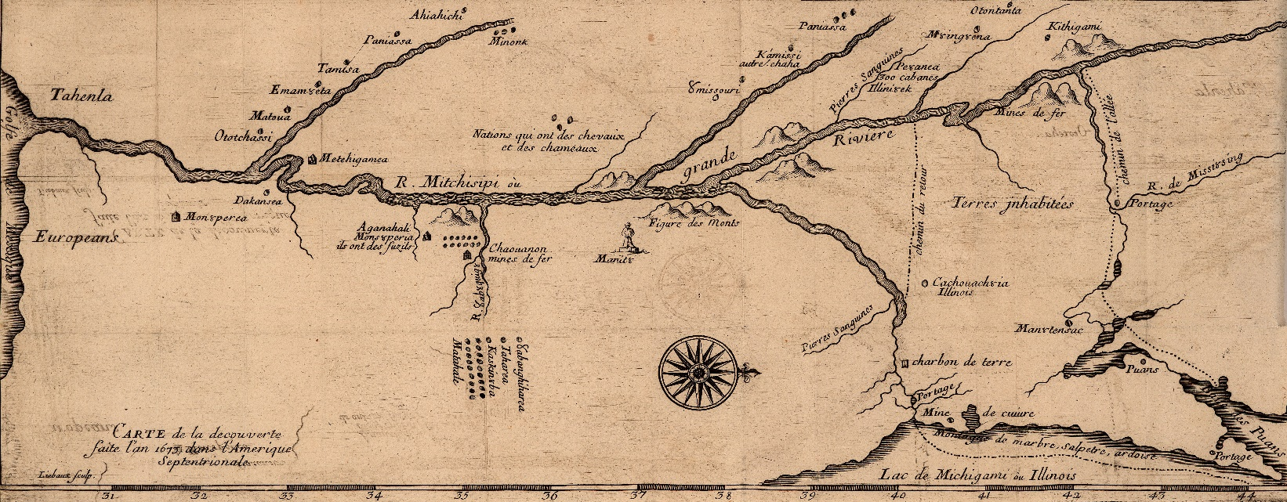

**Home Vita Publications Public Talks Consulting & Media Contact**

**Vita**

**Employment**

* Professor, Milwaukee School of Engineering, 2003-Present
* Adjunct Professor, Marquette University, 1997-2003
* Adjunct Professor, Lakeland College, 2003-2004
* Adjunct Professor, University of Wisconsin-Milwaukee, 1997
* Research Assistant, Wisconsin Indian Resources Project, Milwaukee Public Museum 1996-1997

**Awards**

* Best Book in General History, Midwest Independent Publishing Association, 2019

(Awarded for *The Misunderstood Mission of Jean Nicolet: Uncovering the Story of the 1634 Journey*, 2018)

* Book of Merit Award, Wisconsin Historical Society, 2018

(Awarded for *The Misunderstood Mission of Jean Nicolet: Uncovering the Story of the 1634 Journey*, 2018)

* Mildred Throne & Charles Aldrich Award, State Historical Society of Iowa, 2017

(Awarded for “Lonely Sentinel: A Military History of Fort Madison, 1808-1813,” 2016)

* Oscar Werwath Distinguished Professor Award, Milwaukee School of Engineering, 2010

**Fellowships**

* Visiting Research Fellow, Eccles Centre for American Studies, British Library, 2021
* Learn German in Germany Program, German Academic Exchange Service, 2014
* Fulbright German Studies Seminar, Fulbright Foreign Scholarship Board, 2012

**Grants**

* Theodore and Anna Grollmann Fund, Milwaukee, Wisconsin, 2015, 2016
* International Leadership Initiative, Milwaukee School of Engineering Servant Leadership, 2015
* State Historical Society of Iowa Research, 2014-2015
* Committee on Baccalaureate Expansion, University of Wisconsin System, 2010

**Professional Associations**

* American Anthropological Association
* American Historical Association
* Organization of American Historians
* American Society for Ethnohistory
* Fulbright Association
* Midwestern History Association
* Midwest Archaeological Conference
* Wisconsin Historical Society
* Wisconsin Archaeological Society
* Iowa State Historical Society
* Milwaukee County Historical Society